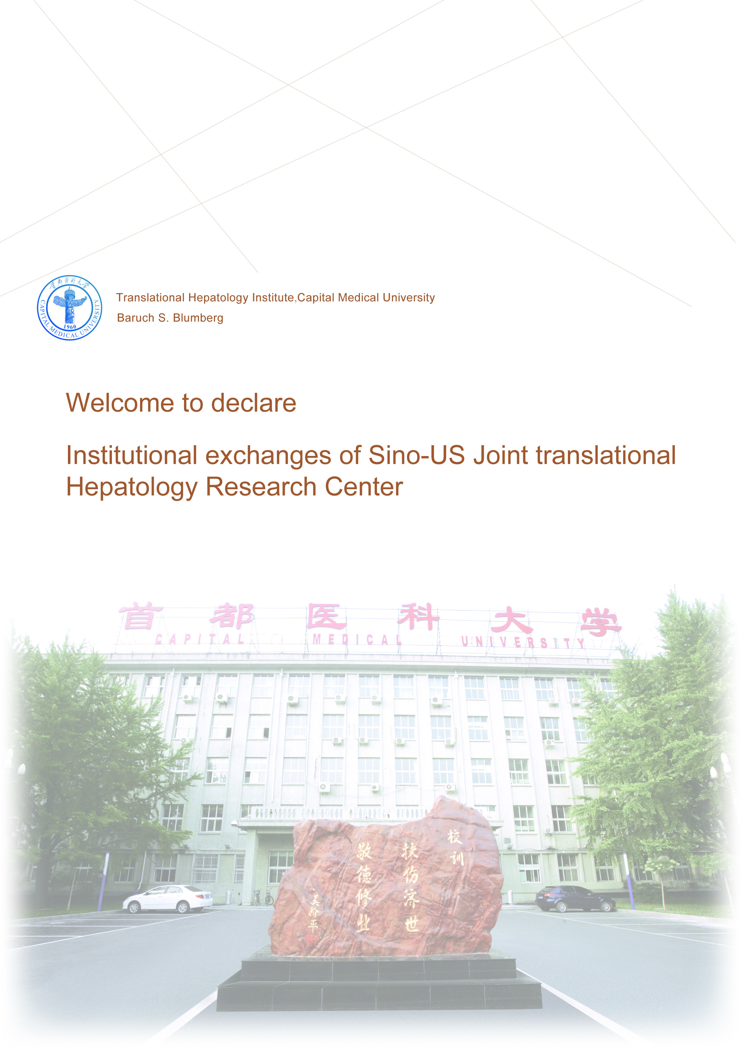
Instructions for 2014-2015 Institutional Exchanges from Sino-US Joint Translational Hepatology Research Center

Translational Hepatology Institute of Capital Medical University (THI-CMU), as the first translational hepatology institute belonging to medical university domestically, is supported by the CMU Science Park. The mission of THI-CMU is to develop, transform, popularize of new technologies and new products in the field of hepatic diseases.
Recently, THI-CMU and Baruch S. Blumberg Institute, located in Philadelphia, USA, have set up Sino-US Joint Translational Hepatology Research Center. Dr. Baruch S. Blumberg was awarded the Nobel Prize in Medicine in 1976 for his discovery of hepatitis B virus. Meanwhile, to strengthen the joint research, personnel training, science and technology exchanges and the transformation of scientific achievements, a program of “Institutional exchanges of Sino-US Joint translational Hepatology Research Center” is initiated by THI-CMU, with the aim to support Chinese physician or researcher to continue study or training in USA. Four or 5 physicians or individuals with Ph.D.s will be selected to participant one year joint research or 2-weeks exchange for year of 2014-2015.

Type of exchange
- Short term exchange: 2 weeks
- Medium-term and long-term joint research: 12 months.
The selected applicants are going to USA around the end of 2014, the specific date will be determined according to the visa application and the arrangement of Baruch S. Blumberg Institute.
The required conditions
- Applicants should be the faculties of national level two or over medical institutions and younger than 50 years old.
- Applicant for medium-term or long term joint research should have attending physician or over technical certification, researcher should have medium grade professional title or over as well as hold degree of master or Ph. D. For short term exchange applicant, a bachelor degree is acceptable. Applicant for medium-term or long term exchange should have excellent English communication skills and pass English test hosted by THI-CMU.
- The medical institution of applicant working for should provide the entire expense for applicant in USA, including transportation, accommodate, etc. Baruch S. Blumberg Institute does not require training fee.
- For each institution one applicant is accepted each year.
- Under the same conditions, members of China national coordinating research group of severe liver diseases have the priority.

Application time
The deadline for submitting application will be Aug. 15, 2014.

Application schedule
- 1. Applicant may down load application form at http://www.cnsld.org. The signed application forms in triplicate may be submitted to THI-CHI by mail or fax, meanwhile please send a completed electrical version to the email address at: thi_cmu@163.com.
- The office of THI-CHI will conduct preliminary review of application, but the program committee will conduct the final review.
- English and experimental skills test. Telephone interview will be required, if necessary, an interview in Beijing may require.
- We will announce the test results in CNSLD website.
- Sign a contract with THI-CMU, prepare for going abroad study.

Contact: Ms. Shuli DUAN, Ms. Haiyang ZHOU
Phone: 010-63051066、63058120
Fax: 010-63051016
Address: Building A, Room 102, Fengtai District, Beijing, China Zip
code：100069

Attachment 1
“Institutional exchanges of Sino-US Joint translational Hepatology Research Center” application form.

Translational Hepatology Institute ，Capital Medical University
Baruch S. Blumberg Institute
Sino-US Joint Translational Hepatology Research Center
Aug 1, 2014

Attachment 1
Application No.:

Application for Institutional Exchanges from Sino-US Joint Translational Hepatology Research Center

Name:
Professional title：
Institution:

The Translational Hepatology Institute at Capital Medical University
July, 2014

Instructions

- The present program is hosted by both Sino-US Joint Translational Hepatology Research Center and US-Sino Joint Translational Hepatology Research Center, called the “Institution” in this document.
- Please provide the highest educational diploma and technical certification you have. The working experiences covers from applicant’s first job to present position, including continuing education and study experiences.
- The Institution takes final responsibility for the information of applicant’s authenticity, correctively. Without the approval and seal of institution human resources, the application is void.
- Please provide the copies of applicant’s birth certification and technical certification.
- The signed application form may be submitted by mail, meanwhile please sends a completed electrical version to the email address at: thi_cmu@163.com. You may down load the application form at http://www.cnsld.org.
- Please attach your one inch electrical photo with the application form.
Type or print of your answers in black ink.
Name |  |  |  |  |  | Gender |  |  |  |  | Nationality |  |  |  | Picture (one inch)
Date of Birth |  | / / |  |  |  |  |  | Professional title |  |  |  |  |  |  | Picture (one inch)
Educational history |  |  |  |  | Diploma |  |  |  |  |  | Administrative posts |  |  |  | Picture (one inch)
No. of Birth Certification |  |  |  |  |  |  |  |  |  |  |  |  |  |  | Picture (one inch)
Passport No. |  |  |  |  |  |  |  |  | Specialty
Institution name |  |  |  |  |  |  |  |  | English ability
Department |  |  |  |  |  |  |  |  | Work experience
Type of exchange | □(1－2 wks) □3month □6month □1year
Specialty | 1 |  |  |  |  |  |  |  | Prior specialty |  |  |  | 1
Specialty | 2 |  |  |  |  |  |  |  |  |  |  |  | 2
Institution address
Zip code |  |  |  |  |  |  | Fax number
Office Phone |  |  |  |  |  |  | Home phone
Cell phone |  |  |  |  |  |  | Email:
Others(Optional) |  | Your QQ number： Wechat number:
Prior training history:

Presently undertaken national or local research projects (title, levels, funding, completion time, etc)

Domestic and foreign academic assignments:

Main academicals achievements (no more than 300 words)

The main academic papers and works published in nearly five years: (no more than 10)

Research interests and study aims:

I carefully read and promise all the information I provide is accuracy and authenticity.

Signature：

Date:
The comments of institution of applicant (including whether assure the expense for abroad study, the accuracy and authenticity of provided information, whether agree applicant to study abroad):

Signature
Human resources: (seal)

Date:

